**NAAN MUDHAVAN**

**ASSIGNMENT DOCUMENT**

**COURSE TITLE** : DIGITAL MARKETING

**COLLEGE CODE** : 1105

**COLLEGE NAME** : GOJAN SCHOOL OF BUSINESS AND TECHNOLOGY

**NM ID** :B7209538F6EF939896445762AE7F52A3

**NAME** : PAVITHRA.L

**REGISTER NUMBER** : 110520106012

**YEAR** : 4TH YEAR

**DEPARTMENT** : ELECTRONICS AND COMMUNICATION ENGINEERING

1. Create a blog or website using Blogspot and Wordpress. Customize the theme design and post new article with 500 words.

Link: <https://beatboxdancestudio.blogspot.com/2023/10/beat-box-dance-studio_7.html>

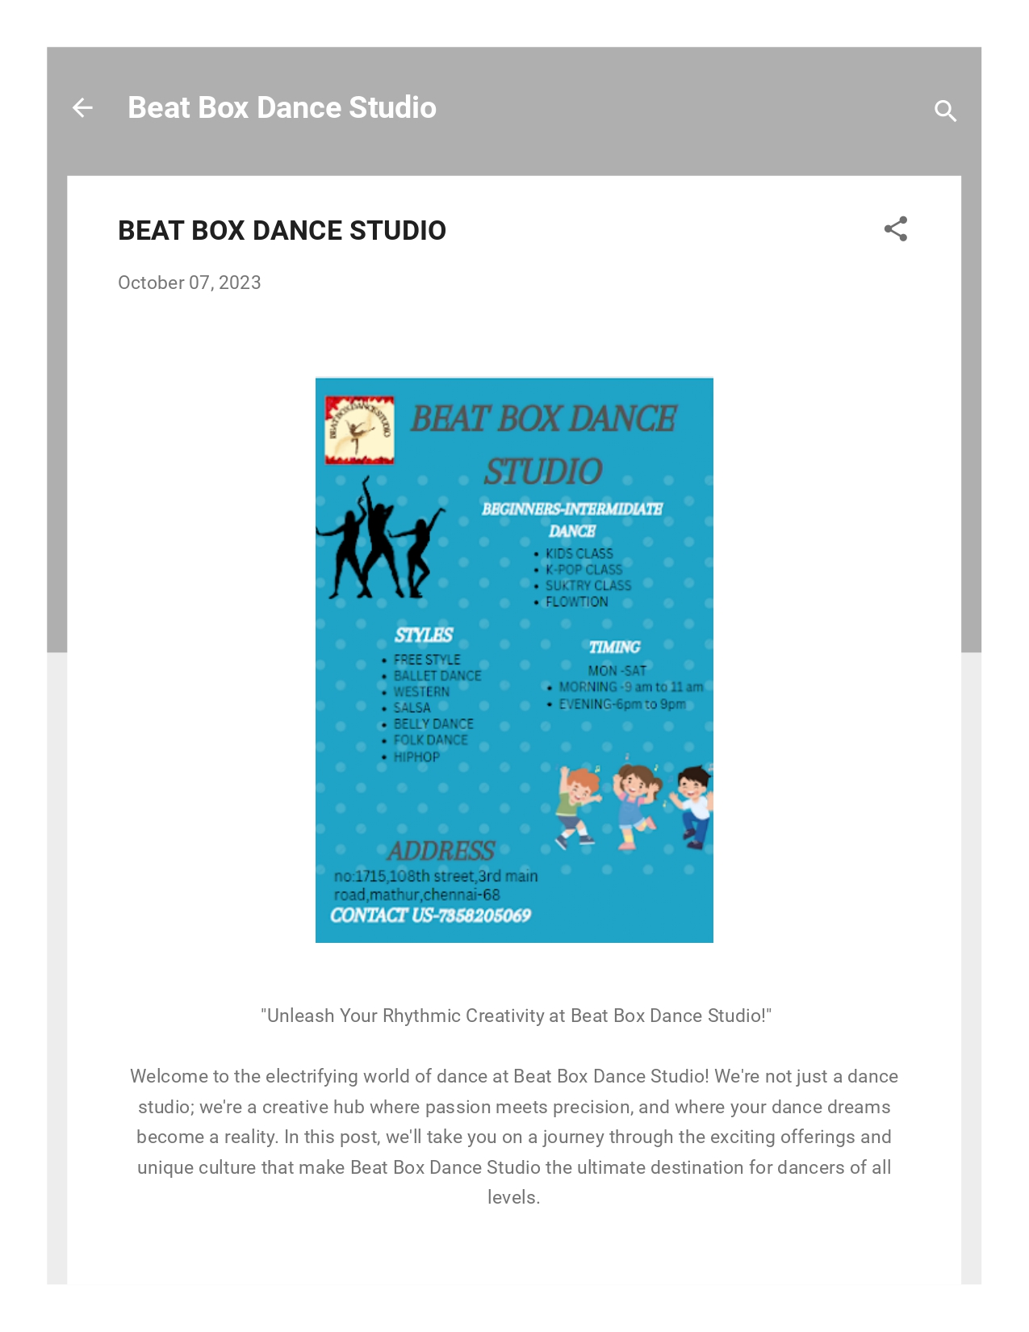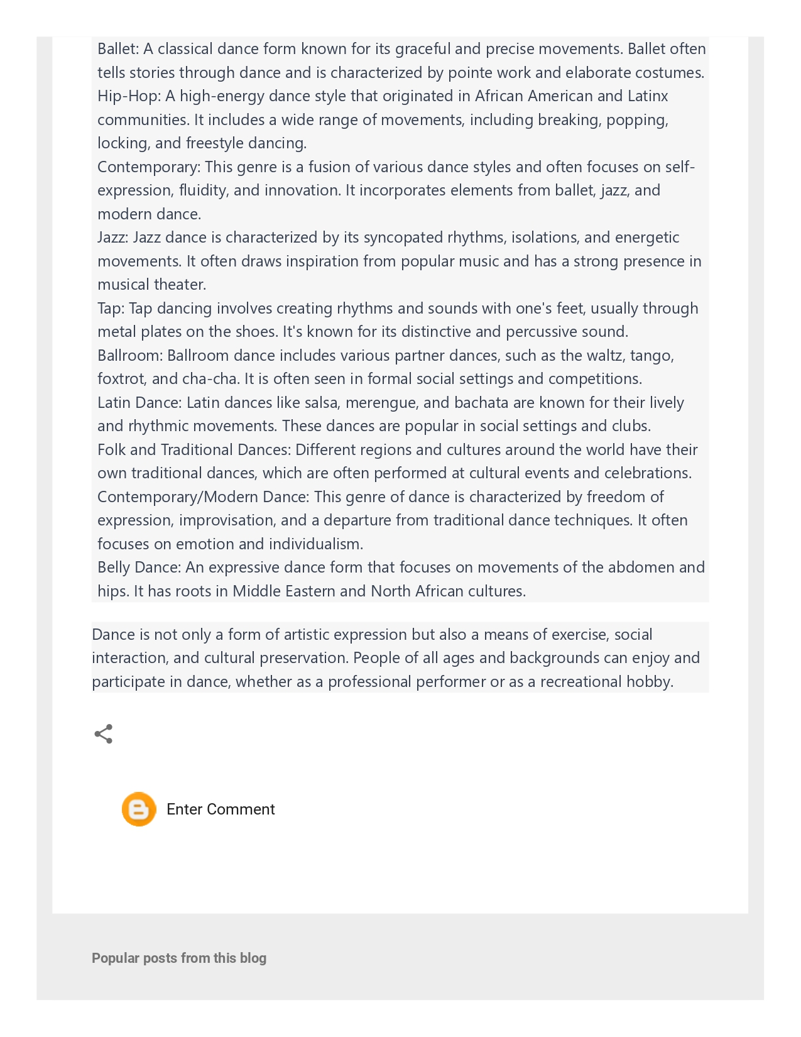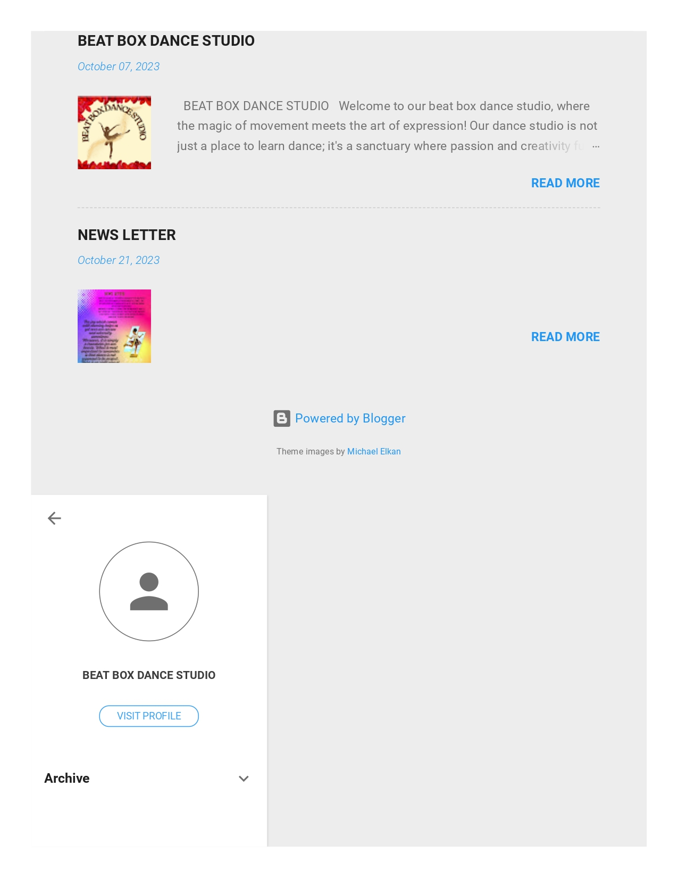

1. Create a New Facebook Business Page and post one social media poster for your brand.

Link: [https://www.facebook.com/profile.php?id=61552359517819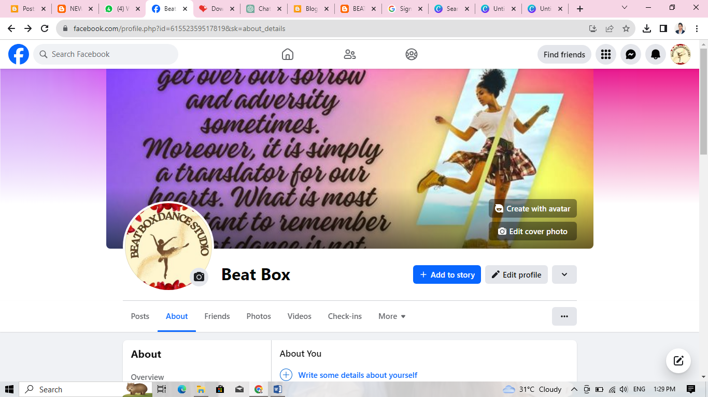](https://www.facebook.com/profile.php?id=61552359517819#)

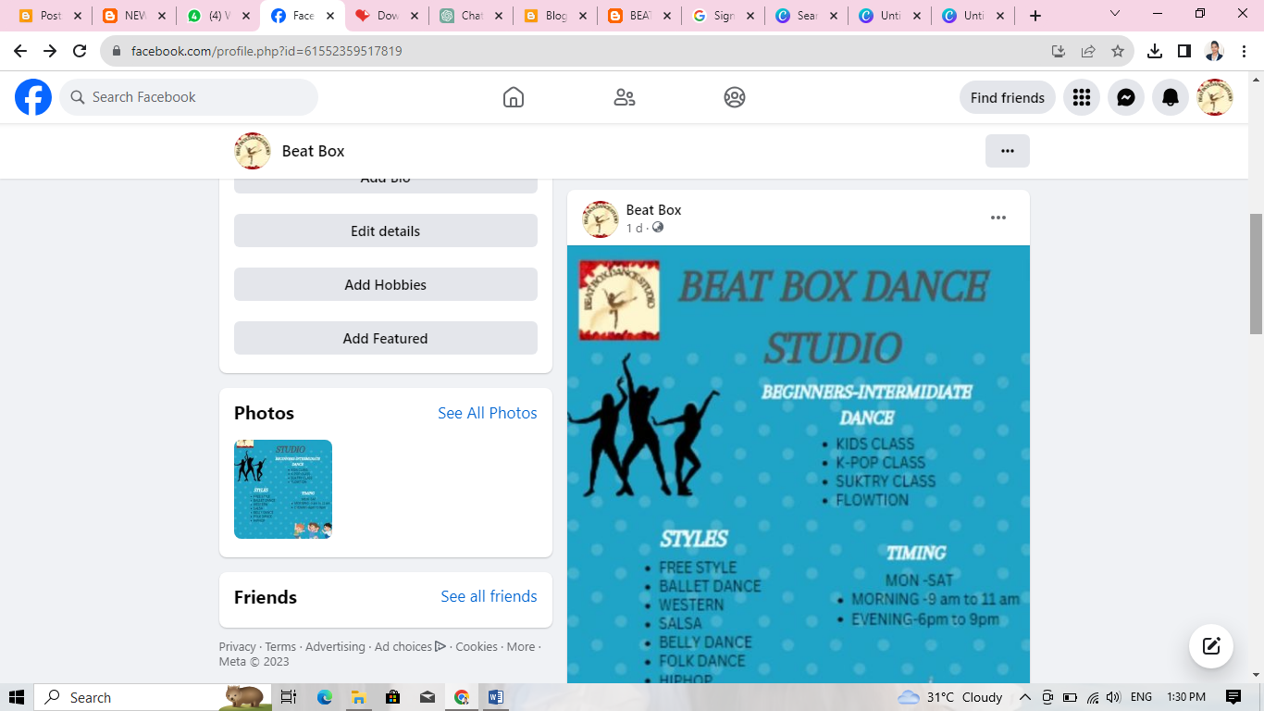

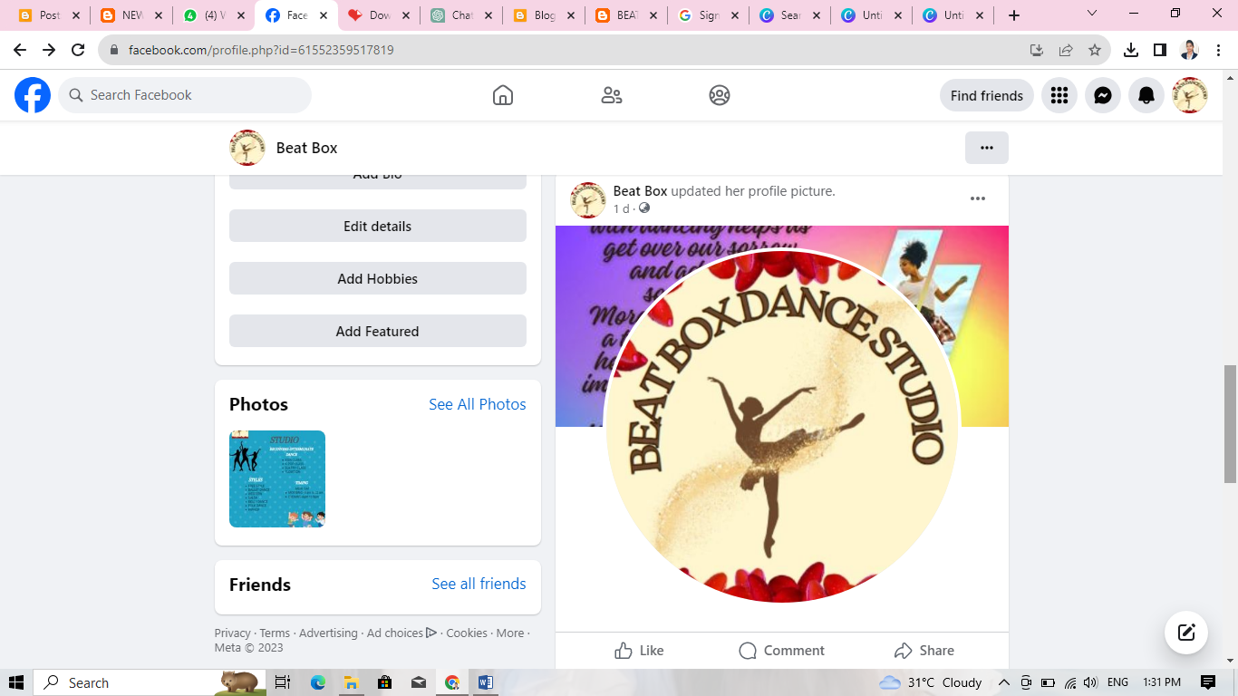

1. Create and design a social media advertisement poster using canva.

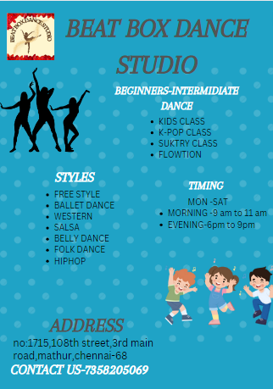

1. Create email newsletter design using MailChimp or canva tool.

Link: [https://beatboxdancestudio.blogspot.com/2023/10/news-letter.html 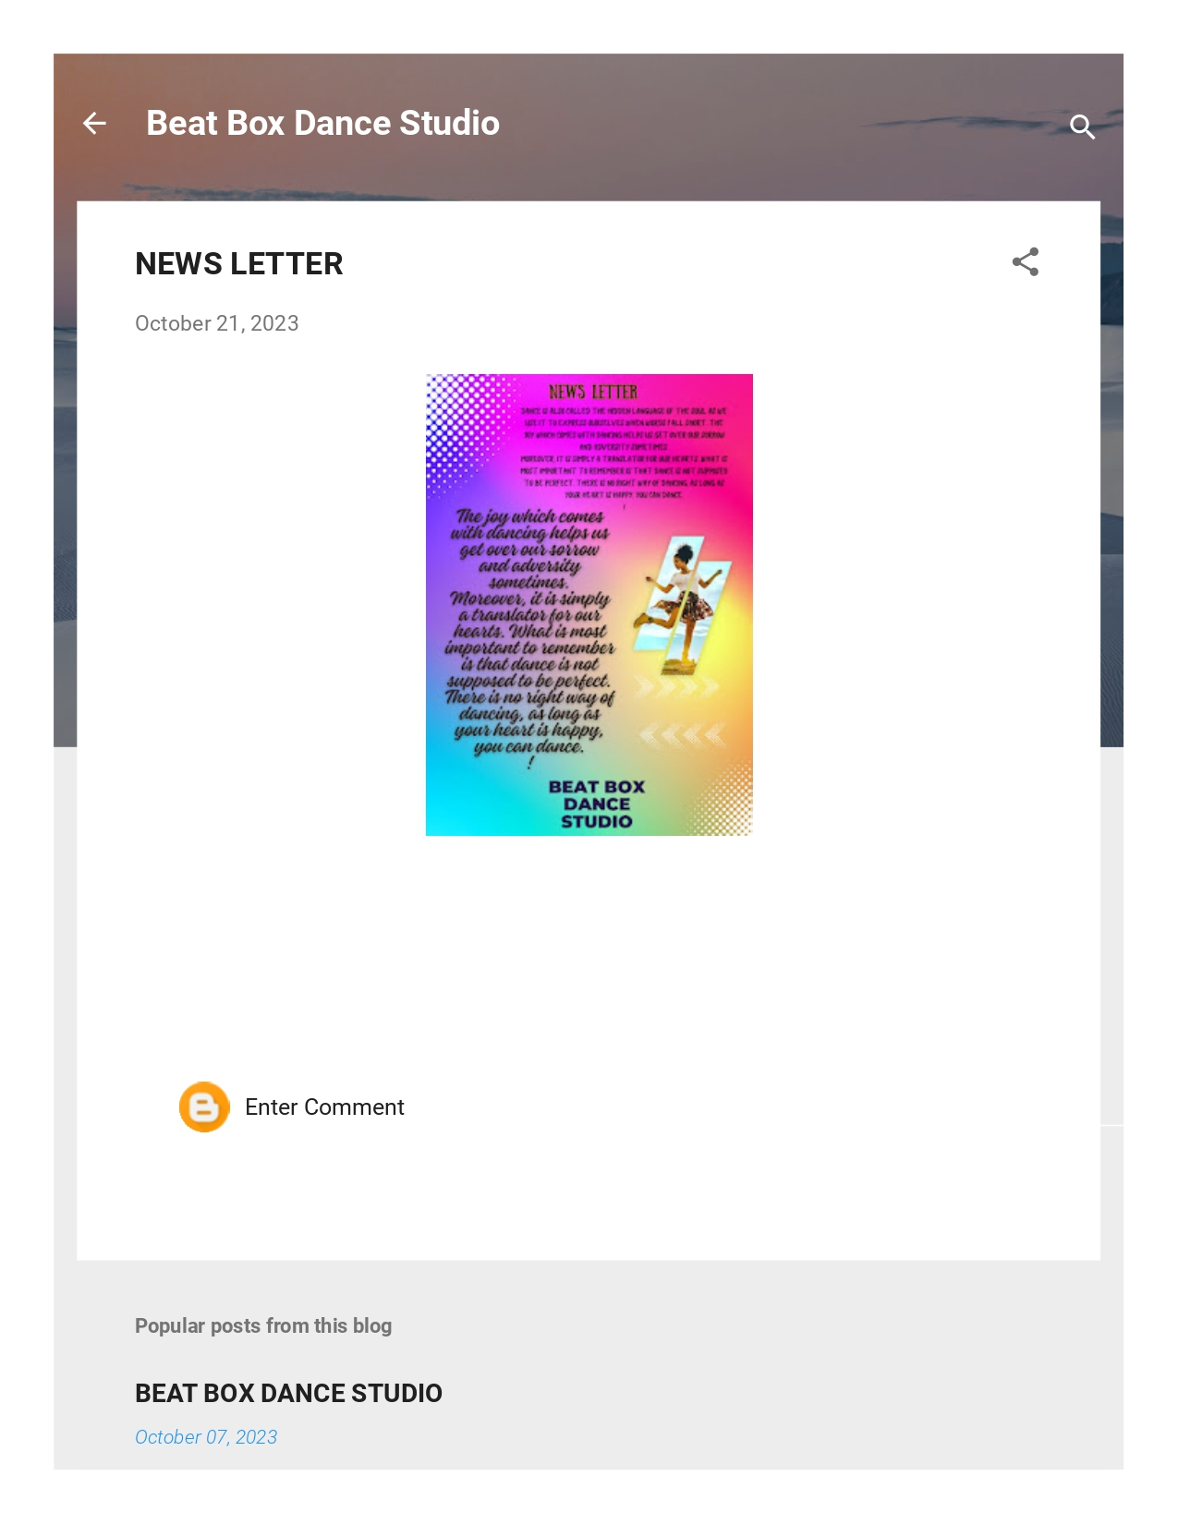](https://beatboxdancestudio.blogspot.com/2023/10/news-letter.html)

